5B
Australian Institute of Physics NSW Branch
6B2024
7BPostgraduate
8BAwards
9BEvent
Schedule

The 2024 Awards Event is sponsored by:
2024 AIP Postgraduate Awards

The NSW AIP Branch will hold its Annual Postgraduate Awards on Tuesday 12 November 2024 at the Concord Golf Club, 190 Majors Bay Road Concord (Entry via Flavelle Street).

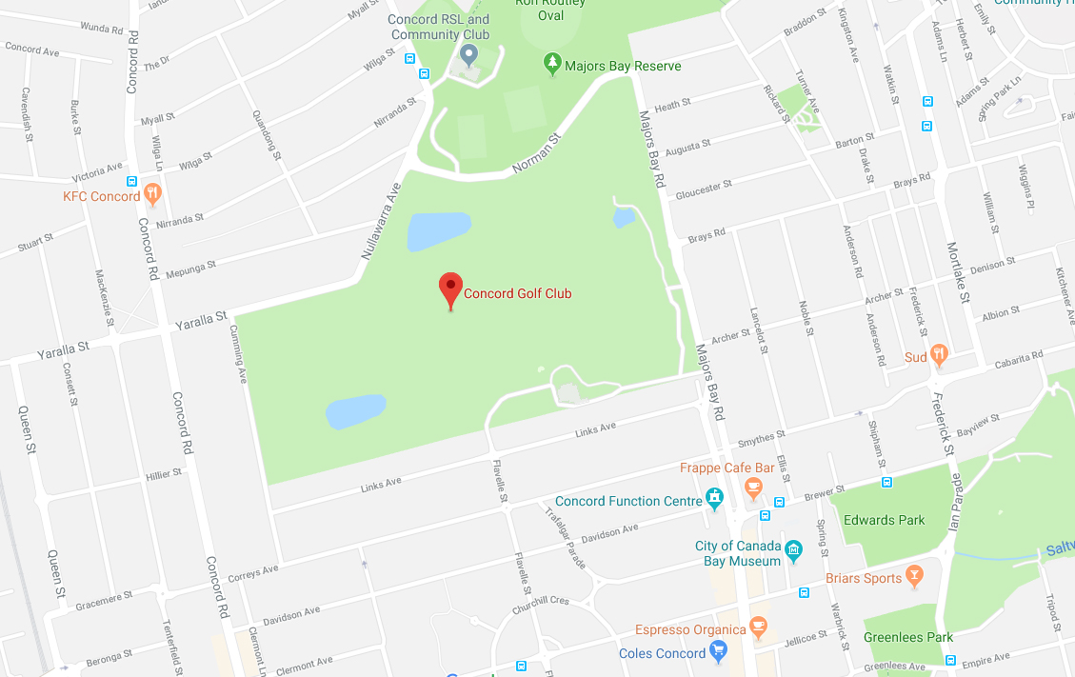

Each University has invited a postgraduate physics nominee to compete for the AIPNSW Postgraduate medal and the RSNSW Jak Kelly prize. These awards have been created to encourage excellence in physics postgraduate work, and all nominees who participate in the Postgraduate Awards Day will receive a special award recognising the nominee’s high standing.

Students will make a 20-minute presentation on their postgraduate research in Physics, and the presentation will be judged on the criteria (1) content and scientific quality, (2) clarity and (3) presentation skills as included in the judges’ criteria.

Event Schedule
- Student presentations at the Concord Golf Club, 190 Majors Bay Road Concord (Entry via Flavelle Street) – 10.00am
- Presentation of Awards and Prizes – 1.00pm

Presentation Procedures

Attendance and Presentation procedures for this event:
- Please bring your presentation on USB or on your own device so it can be connected to the Club’s data projector / screen.

2024 Judging Panel

- Dr Jesse Shore – Prismatic Sciences
- Tibor Molnar – Honorary Research Associate, School of Humanities, University of Sydney
- Dr Shaila Ackhter – Australian Institute of Physics NSW
- Dr Erik Aslaksen – The Royal Society of New South Wales
The 2024 Awards Event is sponsored by:

Criteria for AIP Postgraduate Awards

All candiates will present a max 20-minute presentation (not including questions). The judges score and rank the candidates according to: (1) Content and Scientific Quality, (2) Clarity and (3) Presentation Skills. The judges combine their results to determine the winner. Decisions by the panel are final.

1. Content and scientific quality are important criteria. The presentation must be interesting, and the material should be seen to be significant within the field of research. Context is important for establishing what the state of current research in the field is and how the described research contributes to and extends current knowledge. The candidate must balance the competing demands of providing a clear explanation to the non-specialist and illustrating the techniques and methods to allow a meaningful assessment of the presenter's own understanding and contributions to the research. The context can be further clarified during the question-and-answer session.

1 = Strongly Disagree
3 = Neither Disagree nor Agree
5 = Strongly Agree
A. Content and Scientific Quality Matrix Total____/20
(i) Interesting 1 2 3 4 5
(ii) Significant 1 2 3 4 5
(iii) Addresses Research Gap/Need 1 2 3 4 5
(iv) Contributes and Extends Knowledge 1 2 3 4 5

2. Clarity is a skill which is required to communicate a subject requiring years of study into a 20-minute presentation. The judges are looking for the presenter's ability to communicate the essence of the research without becoming excessively encumbered with detail. A proper introduction, good exposition and meaningful conclusions are important factors in providing a clear presentation.

B. Clarity Matrix Total____/20
(v) Communicates Essence 1 2 3 4 5
(vi) Good Introduction 1 2 3 4 5
(vii) Good Exposition and Explanations 1 2 3 4 5
(viii) Meaningful Conclusion 1 2 3 4 5

3. Presentation skills include the best use of audio-visual aids, speaking ability, eye contact, efficient use of time, projecting a professional and confident attitude, preparedness and response to questions.

C. Presentation Skills Matrix Total____/20
(ix) Preparation and Use of Time 1 2 3 4 5
(x) Use of Visuals 1 2 3 4 5
(xi) Professional and Confident 1 2 3 4 5
(xii) Response to Questions 1 2 3 4 5

Postgraduate Awards Nomination Form

PLEASE complete and return (by email) this NOMINATION FORM for your nominee by 12th October.

Candidates: Please email the title and 300 word abstract of your presentation by 12th October to Dr Frederick Osman on
aip_branchsecretary_nsw@aip.org.au

NAME OF THE NOMINEE | Mr./Mrs./Ms.
UNIVERSITY

DEPARTMENT/SCHOOL

PHONE No. | Area Code: ( )
E-MAIL

TITLE

ABSTRACT (300 words) | Please include text or any figures below.
SUPERVISOR or  HEAD OF THE DEPARTMENT/SCHOOL | Prof. /Assoc. Prof. /Dr. /Mr /Mrs /Ms:  Comments:

IMPORTANT

Nominations and 300-word abstracts are to be emailed to the Awards Convenor Dr Frederick Osman on

aip_branchsecretary_nsw@aip.org.au

Further details regarding the event schedule and registration will be provided after the nominations close.

THE AUSTRALIAN INSTITUTE OF PHYSICS
POSTGRADUATE AWARDS NOMINATION FORM

Please include 300-word abstract below:

